Adding Menu Items to the CCE Kiosk

The Purpose of this document is to walk users through adding new menu items to the CCE Kiosk. If you have not already you will want to read the section on the CCE kiosk over view along with the adding new photos help documents. The process of adding new Menu Items is a bit technical so some knowledge of HTML, and JavaScript would be helpful but is not required. You will want to add menu items if you have new areas of content that you want to add to the CCE kiosk. You may also want to add a broad new category that calls for its own menu. This help document will show you how to do both.

# Adding new menu items to the main menu

Adding a new menu item to the main menu is a little bit simpler so we will start there. Before you add a new menu item to the main menu you would will want to make sure that a new submenu is necessary. Before adding a new menu item to the main menu (and a whole new submenu) ask yourself “is there an existing menu item this content might belong under?” If the answer is no then you need to add a new menu item to the main menu and a whole new submenu to the kiosk. This section of the help documents will show you how to add a new menu to the main menu. The next section will show you how to populate the new submenu.

To start identify the title of the new menu item and find a picture that represents the new topic. Make sure the picture isn’t bigger than 300 pixels on its longest size (to resize use MS paint). Place this file in the MenuItems folder and give it a name that relates to the name of your new menu.

Once you have done this navigate to the Javascript file and open kiosk.js in notepad or notepad++, which ever you prefer. At the top of the page you will see a switch statement that looks like this:

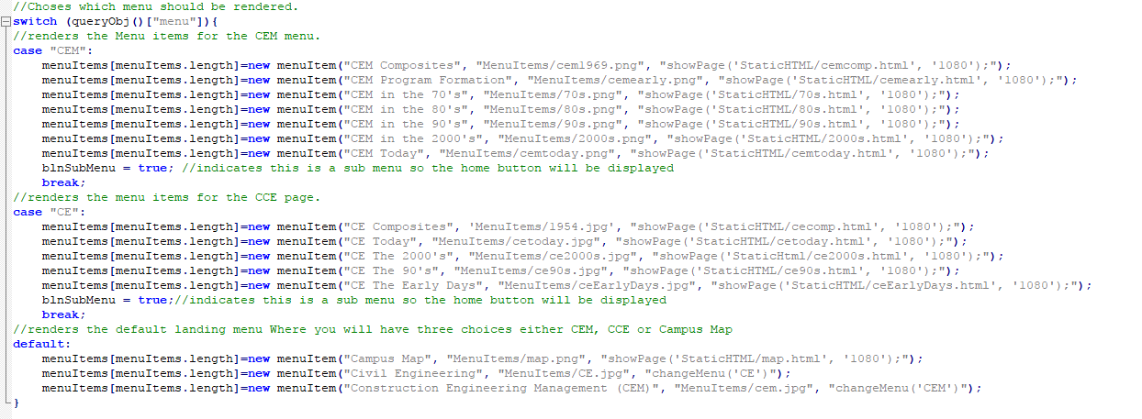

Find the default Case for the switch statement. This is where the menu items for the default menu are created. To create a new menu Item enter a new line with the following code in it:

menuItems[menuItems.length] = new menuItem(“*Name of your menu Item Here”*, ”MenuItems/*The Name of your Menu Item.jpg”*, “changeMenu(‘*The Name of the new menu that we will specify later’*);”);

Now you will need to add a case for the new menu to the switch statement. Once you do this you will replace the text in the change menu function above that is in italics to the name of the case you specified for your submenu. To add a new submenu add the following line of code to the case statement somewhere above the default case:

case “*Your Case Here”*:

Replace your case here with whatever you would like to call your sub menu and be sure to change the text in the menu item you added to the default case for the change page function. Once you have done this your new menu item should display on the main menu and you should be able to navigate to the page. Currently the page will be blank we will address that in the next section. If you encounter any errors make sure that your file names are spelled correctly and that the code is typed correctly into the code. Also double check that the code is typed correctly even a one character error might cause the code to fail.

# Add menu items to a sub menu

In this section we will show you how to add new menu items to submenus. We will also show you how to populate new submenus that have been added to the main menu.

First identify the name of the menu item you would like to add and find a picture that represents that topic. Then put that picture, which should be no bigger than 300 pixels on its longest side, to the menuItems folder. Next create a directory where you will add the photos for the new slide show that the menu items will link to. Give this directory a name that relates to the new menu item you are adding. Drop all the photos you would like to add in this directory.

Next navigate to the Javasript folder and open kiosk.js in notepad or notepad++ which ever you prefer. Find the case statement at the top of the file like the one shown below:



Once you find the case statement find the category of the submenu that you would like to add a menu item to. For instance if you wanted to add a CEM Events menu item you would want to add that to section that says “case “CEM”:. Once you have identified the case you would like to add the new menu item for add the following line of code below that case, replacing the italics with the information relevant to your menu item:

menuItems[menuItems.length] = new menuItem(“*Name of your menu Item Here”*, ”MenuItems/*The Name of your Menu Item.jpg”*, “showPage(‘*TheNameOfYourMenuITem.html’*);”);

Be careful to copy this character for character or it will not work. Once you’ve created the new menu item you will need to create an HTML page for the page to load when you click on the HTML page. TO do this copy the html page from the templates page and paste it in the staticHTML file. Then rename it to the name of the menu item you just created. Make sure it’s the same name as the name in the showPage function in the earlier step or it will not display when you click the menu item. After creating the HTML file you will need to add a new preloading file to the Javascript folder. To do this copy the preloading.js file from the templates folder and follow the instructions at the top of the page. Make sure to rename the file to a name that is relevant to the new html page you just created as it will need to be used in that file. After finishing the Java script file go back to the HTML file and fill in the relevant information. The information that needs to be filled in will say YOUR at the start and then a description of what needs to be put there. After doing these things you your new menu item should be up and running.

To populate a new submenu repeat the process above until